Functional Models
“2D to 3D Time Series Classification Using CNN with Streamlit Dashboard”
Dharmic Chowdary Katta, Systems Analyst
February 10, 2026

- Use Case Diagram
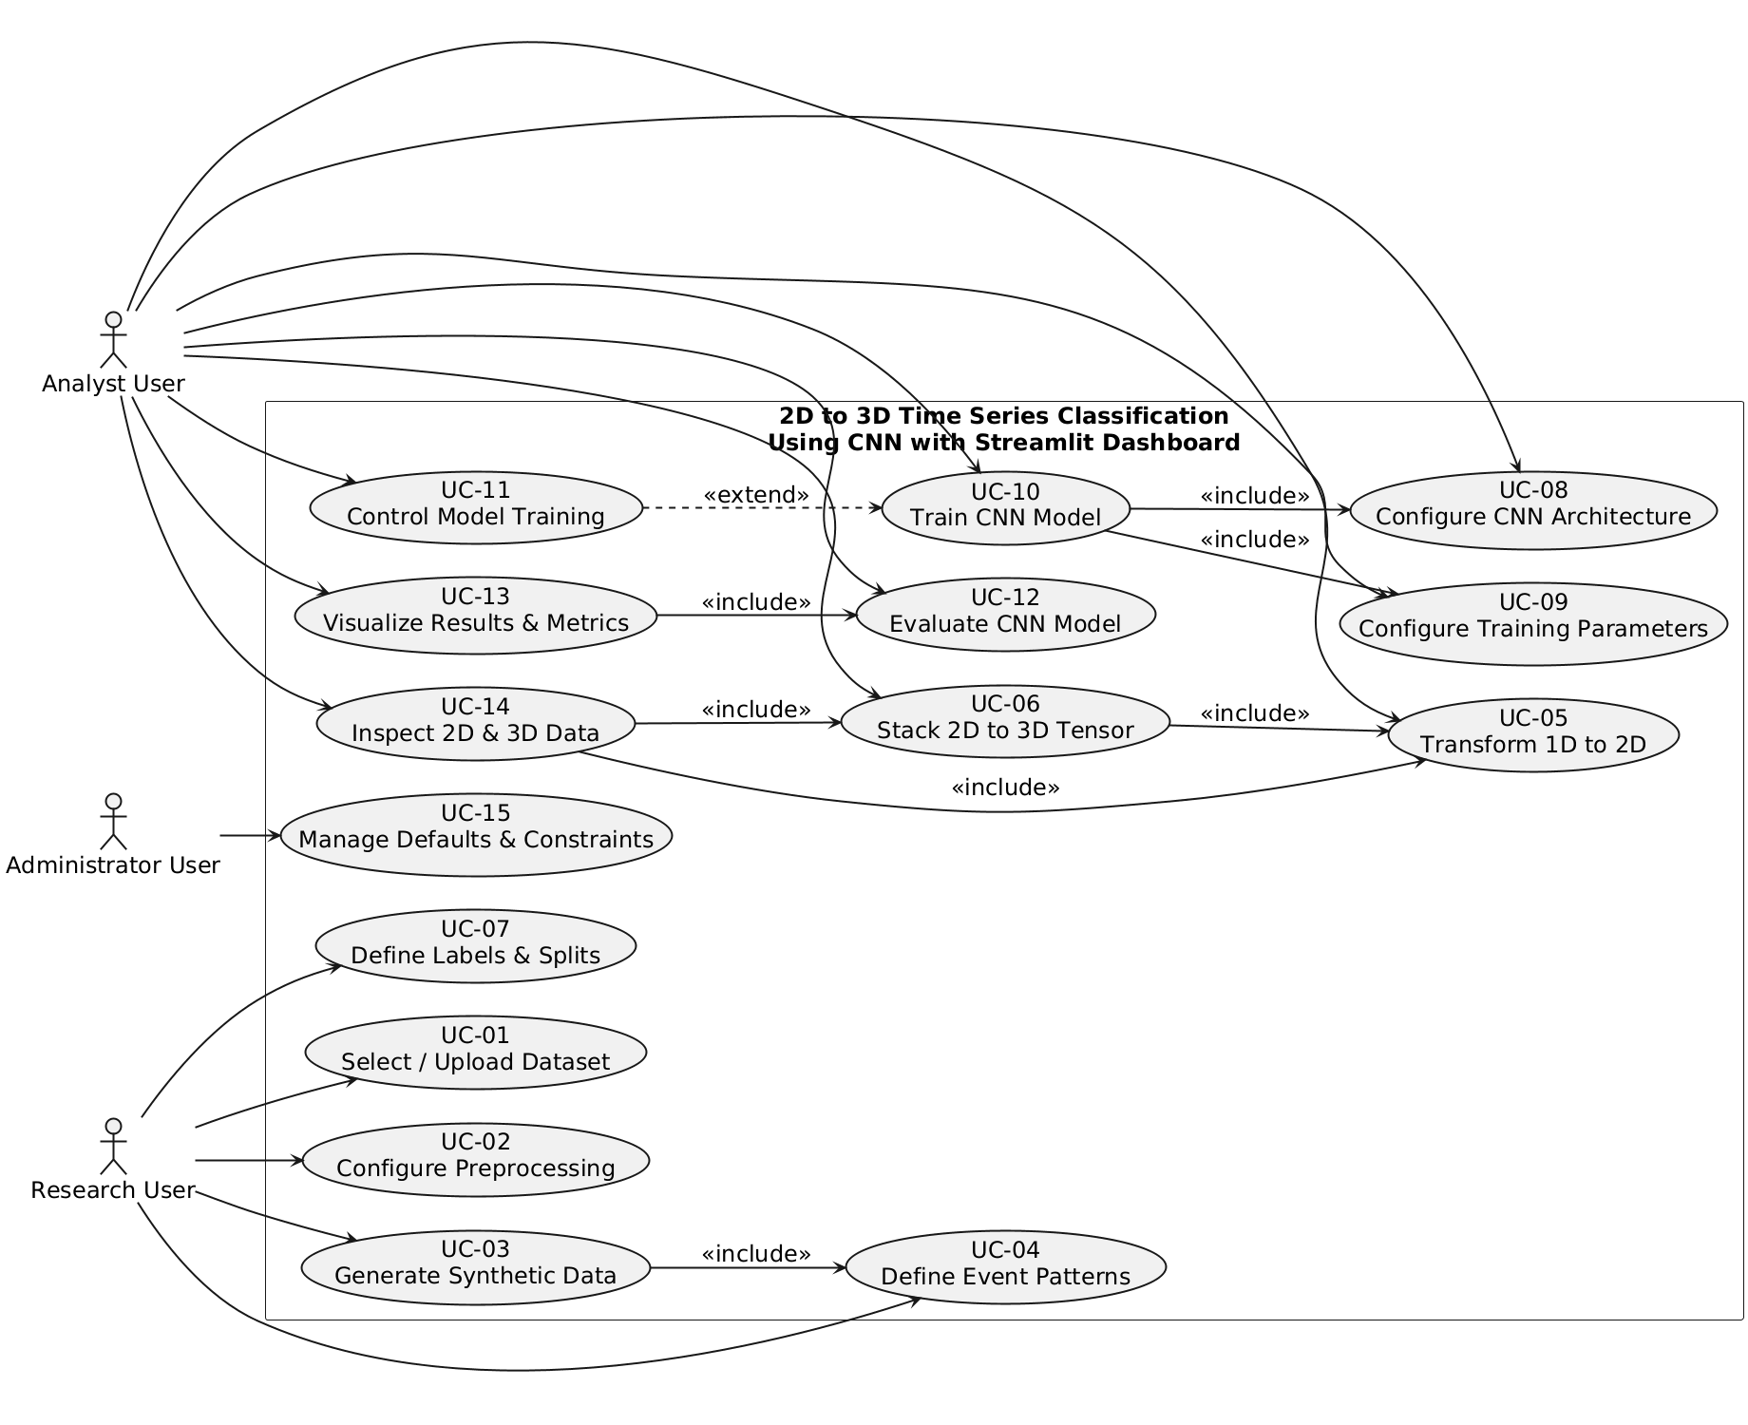
Diagram 1: Use Case Diagram for “2D to 3D Time Series Classification Using CNN with Streamlit Dashboard”
- Use Case Description
Use Case - 1
Use Case Name: Select or Upload Time-Series Dataset |  | ID:UC1 | Importance Level: High
Primary Actor: Research User | Use Case Type: Business
Stakeholders and Interests: The Research User is interested in providing valid and usable time-series data for analysis and experimentation within the system. The organization is interested in ensuring that the dataset used for processing is correctly formatted, accessible, and suitable for subsequent preprocessing, transformation, and model training activities. The system stakeholder is interested in maintaining data integrity and preventing invalid or incompatible datasets from entering the processing pipeline.
Brief Description: This use case allows the Research User to either select a publicly available labeled time-series dataset or upload a local CSV file into the system for further processing and analysis..
Trigger: The Research User decides to begin a new experiment or analysis session.
Type: External
Relationships:
Association: Research User → Use Case 1 Select or Upload Time-Series Dataset
Include: None
Extend: None
Generalization: None
Normal Flow of Events:
- The Research User initiates the dataset selection process.
- The system displays options to select a public dataset or upload a local CSV file.
- The Research User selects a public dataset or uploads a local dataset file.
- The system validates the dataset format and structure.
- The system stores the dataset for use in subsequent processing steps.
SubFlows:
S-1: The system performs basic validation to ensure the dataset is readable and formatted correctly.
Alternate/Exceptional Flows:
If the uploaded or selected dataset is invalid or unsupported, the system displays an error message and requests the Research User to select or upload a valid dataset.

This use case description is covering the requirements – FR-1, FR-2.

Use Case - 2
Use Case Name: Configure Data Preprocessing |  | ID:UC-2 | Importance Level: High
Primary Actor: Research User | Use Case Type: Business
Stakeholders and Interests: The Research User is interested in defining appropriate segmentation and normalization settings so that time-series data is prepared correctly for analysis and model training. The organization is interested in ensuring consistent and repeatable preprocessing steps that improve data quality and experimental validity. The system stakeholder is interested in applying preprocessing rules accurately and preventing invalid configurations that could affect downstream transformations and model performance.
Brief Description: This use case allows the Research User to configure preprocessing parameters, including time-series segmentation and normalization techniques, to prepare raw data for transformation and model training.
Trigger: The Research User has selected or uploaded a time-series dataset and is ready to prepare the data for analysis.
Type: External
Relationships:
Association: Research User → Use Case 2 Configure Data Preprocessing
Include: None
Extend: None
Generalization: None
Normal Flow of Events:
- The Research User initiates the data preprocessing configuration process.
- The system displays available segmentation and normalization options.
- The Research User selects segmentation parameters such as window size.
- The Research User selects a normalization technique.
- The system validates the selected preprocessing parameters.
- The system saves the preprocessing configuration for later execution.
SubFlows:
S-1: The system checks that preprocessing parameters fall within allowed limits.
Alternate/Exceptional Flows:
If invalid or unsupported preprocessing parameters are selected, the system displays an error message and requests the Research User to correct the configuration.

This use case descriptio n is covering the requirements – FR-3, FR-4.

Use Case - 3
Use Case Name: Generate Synthetic Time-Series Data |  | ID:UC-3 | Importance Level: Medium
Primary Actor: Research User | Use Case Type: Business
Stakeholders and Interests: The Research User is interested in generating labeled synthetic time-series data to support experimentation, testing, and demonstration without relying on external datasets. The organization is interested in enabling controlled data generation that avoids licensing restrictions while supporting repeatable experiments. The system stakeholder is interested in generating valid and well-structured synthetic datasets that can be processed, transformed, and used reliably in later stages of the system.
Brief Description: This use case allows the Research User to generate labeled synthetic time-series data by specifying configurable parameters such as frequency, duration, and noise level.
Trigger: The Research User requires synthetic data for training, testing, or demonstration purposes.
Type: External
Relationships:
Association: Research User → Use Case 3 Generate Synthetic Time-Series Data
Include: Use Case 4 Define Synthetic Event Patterns
Extend: None
Generalization: None
Normal Flow of Events:
- The Research User initiates the synthetic data generation process.
- The system prompts the Research User to define synthetic data parameters.
- The Research User specifies frequency, duration, and noise parameters.
- The system invokes Use Case 4 Define Synthetic Event Patterns.
- The system generates labeled synthetic time-series data based on the provided parameters.
- The system stores the generated data for later processing.
SubFlows:
S-1: The system validates that synthetic data parameters are within acceptable limits.
Alternate/Exceptional Flows:
If invalid parameters are provided, the system displays an error message and requests corrected input from the Research User.

This use case description is covering the requirements – FR-5, FR-6.

Use Case - 4
Use Case Name: Define Synthetic Event Patterns |  | ID:UC-4 | Importance Level: Medium
Primary Actor: Research User | Use Case Type: Business
Stakeholders and Interests: The Research User is interested in defining meaningful event patterns that can be embedded within synthetic time-series data to simulate real-world scenarios. The organization is interested in ensuring that synthetic datasets reflect realistic temporal behaviors that support valid experimentation and evaluation. The system stakeholder is interested in accurately embedding event patterns into generated data in a controlled and repeatable manner.
Brief Description: This use case allows the Research User to define event patterns that will be embedded within synthetic time-series data during the data generation process.
Trigger: The Research User chooses to specify event patterns while generating synthetic time-series data.
Type: External
Relationships:
Association: Research User → Use Case 4 Define Synthetic Event Patterns
Include: None.
Extend: None
Generalization: None
Normal Flow of Events:
- The Research User initiates the event pattern definition process.
- The system displays available event pattern configuration options.
- The Research User defines event characteristics such as timing and shape.
- The system validates the defined event patterns.
- The system saves the event pattern definitions for use during synthetic data generation.
SubFlows:
S-1: The system verifies that event patterns are compatible with synthetic data parameters.
Alternate/Exceptional Flows:
If event pattern definitions are invalid or incompatible, the system displays an error message and requests corrected input from the Research User.

This use case description is covering the requirements – FR-6.

Use Case - 5
Use Case Name: Transform 1D Data to 2D Representation |  | ID:UC-5 | Importance Level: High
Primary Actor: Analyst User | Use Case Type: Business
Stakeholders and Interests: The Analyst User is interested in transforming one-dimensional time-series data into two-dimensional matrix representations to reveal local and global patterns. The organization is interested in enabling structured data transformations that support advanced analytical and machine learning techniques. The system stakeholder is interested in performing accurate and efficient transformations that produce valid 2D representations suitable for further processing.
Brief Description: This use case allows the Analyst User to convert segmented one-dimensional time-series data into two-dimensional matrix representations for visualization and model input preparation.
Trigger: The Analyst User is ready to transform preprocessed time-series data into a two-dimensional format.
Type: External
Relationships:
Association: Analyst User → Use Case 5 Transform 1D Data to 2D Representation
Include: None
Extend: None
Generalization: None
Normal Flow of Events:
- The Analyst User initiates the 2D transformation process.
- The system retrieves the preprocessed time-series data.
- The system applies the defined transformation method to generate 2D matrices.
- The system validates the generated 2D representations.
- The system stores the 2D matrices for later use.
SubFlows:
S-1: The system checks that input data is available and properly preprocessed.
Alternate/Exceptional Flows:
If required preprocessing has not been completed or data is unavailable, the system displays an error message and prevents the transformation.

This use case description is covering the requirements – FR-7, FR-8.

Use Case - 6
Use Case Name: Stack 2D Data into 3D Tensor |  | ID:UC-6 | Importance Level: High
Primary Actor: Analyst User | Use Case Type: Business
Stakeholders and Interests: The Analyst User is interested in combining multiple two-dimensional representations into a three-dimensional tensor to capture temporal evolution in the data. The organization is interested in enabling structured 3D data representations that support advanced convolutional neural network processing. The system stakeholder is interested in stacking 2D data accurately and consistently to produce valid 3D tensors suitable for model training and evaluation.
Brief Description: This use case allows the Analyst User to stack previously generated two-dimensional matrix representations into a three-dimensional tensor for use in CNN model training and analysis.
Trigger: The Analyst User has completed the generation of 2D representations and is ready to form 3D tensors.
Type: External
Relationships:
Association: Analyst User → Use Case 6 Stack 2D Data into 3D Tensor
Include: Use Case 5 Transform 1D Data to 2D Representation
Extend: None
Generalization: None
Normal Flow of Events:
- The Analyst User initiates the 3D tensor creation process.
- The system retrieves the available 2D matrix representations.
- The system stacks the 2D matrices according to the specified temporal depth.
- The system validates the structure and dimensions of the 3D tensor.
- The system stores the 3D tensor for subsequent model processing.
SubFlows:
S-1: The system verifies that sufficient 2D matrices exist to form a valid 3D tensor.
Alternate/Exceptional Flows:
If insufficient or incompatible 2D data is available, the system displays an error message and stops the stacking process.

This use case description is covering the requirements – FR-9, FR-10.

Use Case - 7
Use Case Name: Define Class Labels and Dataset Splits |  | ID:UC-7 | Importance Level: High
Primary Actor: Research User | Use Case Type: Business
Stakeholders and Interests: The Research User is interested in defining clear class labels and assigning time-series data to training, validation, and testing subsets to support accurate model training and evaluation. The organization is interested in ensuring that datasets are structured correctly to maintain experimental validity and reproducibility. The system stakeholder is interested in applying label definitions and dataset splits consistently to prevent data leakage and support reliable analysis results.
Brief Description: This use case allows the Research User to define class labels and assign time-series data segments to training, validation, and testing datasets.
Trigger: The Research User has prepared the dataset and is ready to organize it for model training and evaluation.
Type: External
Relationships:
Association: Research User → Use Case 7 Define Class Labels and Dataset Splits
Include: None
Extend: None
Generalization: None
Normal Flow of Events:
- The Research User initiates the dataset labeling and splitting process.
- The system displays options to define class labels.
- The Research User assigns class labels to time-series segments.
- The Research User specifies proportions for training, validation, and testing datasets.
- The system validates the dataset split configuration.
- The system saves the labeled and split datasets.
SubFlows:
S-1: The system checks that dataset splits meet required proportion constraints.
Alternate/Exceptional Flows:
If dataset splits are invalid or inconsistent, the system displays an error message and requests corrected input from the Research User.

This use case description is covering the requirements – FR-11, FR-12.

Use Case - 8
Use Case Name: Configure CNN Architecture |  | ID:UC-8 | Importance Level: High
Primary Actor: Analyst User | Use Case Type: Business
Stakeholders and Interests: The Analyst User is interested in defining an appropriate convolutional neural network architecture that balances classification accuracy with computational efficiency. The organization is interested in ensuring that model architectures are configurable, reusable, and suitable for execution on standard hardware. The system stakeholder is interested in validating architectural configurations to prevent incompatible or resource-intensive designs.
Brief Description: This use case allows the Analyst User to configure the structure of the convolutional neural network by specifying layers, kernel dimensions, and activation functions.
Trigger: The Analyst User is ready to define the CNN architecture before initiating model training.
Type: External
Relationships:
Association: Analyst User → Use Case 8 Configure CNN Architecture
Include: None
Extend: None
Generalization: None
Normal Flow of Events:
- The Analyst User initiates the CNN architecture configuration process.
- The system displays available configuration options for CNN layers and kernels.
- The Analyst User specifies the number of layers and filter sizes.
- The Analyst User selects activation functions for the network.
- The system validates the CNN architecture configuration.
- The system saves the CNN architecture settings for training.
SubFlows:
S-1: The system checks that the CNN architecture complies with defined system constraints.
Alternate/Exceptional Flows:
If the configured architecture exceeds system constraints or is invalid, the system displays an error message and requests revised input from the Analyst User.

This use case description is covering the requirements – FR-13, FR-14, FR-15.

Use Case - 9
Use Case Name: Configure Training Parameters |  | ID:UC-9 | Importance Level: High
Primary Actor: Analyst User | Use Case Type: Business
Stakeholders and Interests: The Analyst User is interested in defining training parameters that control how the CNN model is trained, including batch size and number of epochs, to balance performance and execution time. The organization is interested in ensuring that training configurations are efficient, repeatable, and suitable for classroom and professional demonstrations. The system stakeholder is interested in enforcing parameter limits to prevent excessive resource usage or system instability.
Brief Description: This use case allows the Analyst User to configure training parameters that govern the execution of the CNN model training process.
Trigger: The Analyst User has finalized the CNN architecture and is ready to define training settings.
Type: External
Relationships:
Association: Analyst User → Use Case 9 Configure Training Parameters
Include: None
Extend: None
Generalization: None
Normal Flow of Events:
- The Analyst User initiates the training parameter configuration process.
- The system displays configurable training options.
- The Analyst User specifies batch size and number of training epochs.
- The system validates the training parameters against system constraints.
- The system saves the training configuration for use during model training.
SubFlows:
S-1: The system checks that training parameters are within allowed limits.
Alternate/Exceptional Flows:
If training parameters exceed defined limits or are invalid, the system displays an error message and requests corrected input from the Analyst User.

This use case description is covering the requirements – FR-16.

Use Case - 10
Use Case Name: Train CNN Model |  | ID:UC-10 | Importance Level: High
Primary Actor: Analyst User | Use Case Type: Business
Stakeholders and Interests: The Analyst User is interested in training the CNN model using the configured parameters to obtain a reliable and accurate model for analysis and demonstration. The organization is interested in ensuring that the training process is stable, reproducible, and produces measurable performance results. The system stakeholder is interested in managing computational resources efficiently while executing the training process without errors.
Brief Description: This use case allows the Analyst User to train the CNN model using the prepared dataset, configured parameters, and defined model architecture.
Trigger: The Analyst User has completed dataset preparation and training parameter configuration.
Type: External
Relationships:
Association: Analyst User → Use Case 10 Train CNN Model
Include: Use Case 9 Configure Training Parameters
Extend: None
Generalization: None
Normal Flow of Events:
- The Analyst User initiates the CNN model training process.
- The system loads the dataset and applies preprocessing.
- The system initializes the CNN model with configured parameters.
- The system executes the training process.
- The system evaluates training progress and performance metrics.
- The system saves the trained model and displays completion status.
SubFlows:
S-1: The system monitors resource usage and training stability.
Alternate/Exceptional Flows:
- If training fails due to invalid parameters or resource limitations, the system stops the process and displays an error message.

This use case description is covering the requirements – FR-17.

Use Case - 11
Use Case Name: Control Model Training |  | ID:UC-11 | Importance Level: Medium
Primary Actor: Analyst User | Use Case Type: Business
Stakeholders and Interests: The Analyst User is interested in controlling the CNN model training process by pausing or stopping execution when needed. The organization is interested in preventing unnecessary resource usage and allowing controlled experimentation. The system stakeholder is interested in handling training control commands safely without corrupting the training state.
Brief Description: This use case allows the Analyst User to pause or stop the ongoing CNN model training process.
Trigger: The CNN model training process is currently in progress.
Type: External
Relationships:
Association: Analyst User → Use Case 11 Control Model Training
Include: None
Extend: Use Case 10 Train CNN Model
Generalization: None
Normal Flow of Events:
- The Analyst User issues a pause or stop command during training.
- The system receives the training control request.
- The system safely pauses or terminates the training process.
- The system preserves the current training state if paused.
- The system releases allocated resources if training is stopped.
- The system notifies the Analyst User of the training status.
SubFlows:
S-1: The system checks whether a training process is active before applying control actions.
Alternate/Exceptional Flows:
If no training process is active, the system displays a message indicating that no action can be performed.

This use case description is covering the requirements – FR-18.

Use Case – 12
Use Case Name: Evaluate CNN Model |  | ID:UC-12 | Importance Level: High
Primary Actor: Analyst User | Use Case Type: Business
Stakeholders and Interests: The Analyst User is interested in evaluating the trained CNN model to understand its predictive performance on unseen data. The organization is interested in obtaining reliable evaluation results to support research findings and demonstrations. The system stakeholder is interested in ensuring that evaluation is performed correctly using the trained model and appropriate datasets without affecting system stability.
Brief Description: This use case allows the Analyst User to evaluate the trained CNN model using test data and generate prediction results and performance metrics.
Trigger: The CNN model has been successfully trained and is ready for evaluation.
Type: External
Relationships:
Association: Analyst User → Use Case 12 Evaluate CNN Model
Include: None
Extend: None
Generalization: None
Normal Flow of Events:
- The Analyst User initiates the model evaluation process.
- The system loads the trained CNN model.
- The system loads the test dataset.
- The system generates predictions using the CNN model.
- The system computes evaluation metrics.
- The system stores evaluation results and displays completion status.
SubFlows:
S-1: The system verifies compatibility between the model and test dataset.
Alternate/Exceptional Flows:
If the trained model or test data is unavailable or invalid, the system displays an error message and stops the evaluation process.

This use case description is covering the requirements – FR-19, FR-20, FR-21.

Use Case - 13
Use Case Name: Visualize Results and Metrics |  | ID:UC-13 | Importance Level: Medium
Primary Actor: Analyst User | Use Case Type: Business
Stakeholders and Interests: The Analyst User is interested in visually analyzing model performance using graphs and metrics for better interpretation of results. The organization is interested in clear and understandable visual outputs for research presentation and evaluation. The system stakeholder is interested in generating visualizations efficiently without affecting system performance.
Brief Description: This use case allows the Analyst User to visualize CNN model evaluation results using charts, plots, and performance metrics.
Trigger: The CNN model evaluation process has been completed.
Type: External
Relationships:
Association: Analyst User → Use Case 13 Visualize Results and Metrics
Include: Use Case 12 Evaluate CNN Model
Extend: None
Generalization: None
Normal Flow of Events:
- The Analyst User requests visualization of evaluation results.
- The system retrieves stored evaluation metrics.
- The system generates visual representations of results.
- The system displays charts and plots to the Analyst User.
- The system allows the Analyst User to inspect visual outputs.
- The system completes the visualization process.
SubFlows:
S-1: The system formats metrics into appropriate visualization types.
Alternate/Exceptional Flows:
If evaluation results are unavailable, the system displays an error message.

This use case description is covering the requirements – FR-22, FR-23, FR-24, FR-29, FR-30.

Use Case - 14
Use Case Name: Inspect 2D and 3D Representations |  | ID:UC-14 | Importance Level: Medium
Primary Actor: Analyst User | Use Case Type: Business
Stakeholders and Interests: The Analyst User is interested in inspecting 2D matrices and 3D tensors generated during data transformation to verify correctness and understand data structure. The organization is interested in transparency of data transformations for research validation. The system stakeholder is interested in providing safe and efficient inspection without altering stored data.
Brief Description: This use case allows the Analyst User to inspect generated 2D and 3D data representations used for CNN training.
Trigger: 2D or 3D data representations have been successfully generated.
Type: External
Relationships:
Association: Analyst User → Use Case 14 Inspect 2D and 3D Representations
Include: Use Case 5 Transform 1D Data to 2D Representation, Use Case 6 Stack 2D Data into 3D Tensor
Extend: None
Generalization: None
Normal Flow of Events:
- The Analyst User selects data inspection options.
- The system loads the requested 2D or 3D representations.
- The system renders visual or tabular views of the data.
- The system displays the representations to the Analyst User.
- The Analyst User inspects the displayed data.
- The system completes the inspection process.
SubFlows:
S-1: The system retrieves data in read-only mode for inspection.
Alternate/Exceptional Flows:
If requested data is unavailable, the system displays an error message.

This use case description is covering the requirements – FR-25, FR-26.

Use Case - 15
Use Case Name: Manage System Defaults and Constraints |  | ID:UC-15 | Importance Level: High
Primary Actor: Administrator User | Use Case Type: Business
Stakeholders and Interests: The Administrator User is interested in managing system-wide defaults, limits, and feature controls to ensure stable and secure system operation. The organization is interested in enforcing consistent policies across users and preventing misuse of system resources. The system stakeholder is interested in applying constraints reliably without disrupting ongoing user activities.
Brief Description: This use case allows the Administrator User to define and manage default settings, operational limits, and system constraints.
Trigger: The Administrator User accesses system administration functions.
Type: External
Relationships:
Association: Administrator User → Use Case 15 Manage System Defaults and Constraints
Include: None
Extend: None
Generalization: None
Normal Flow of Events:
- The Administrator User initiates system configuration management.
- The system displays configurable defaults and constraints.
- The Administrator User modifies system settings.
- The system validates the updated configurations.
- The system applies the changes.
- The system saves the updated settings.
SubFlows:
S-1: The system checks for conflicts with active system processes.
Alternate/Exceptional Flows:
If invalid or conflicting settings are provided, the system rejects the changes and displays an error message.

This use case description is covering the requirements – FR-31, FR-32, FR-33, FR-34, FR-35, FR-36, FR-37, FR-38, FR-39, FR-40.

2. Activity Diagram
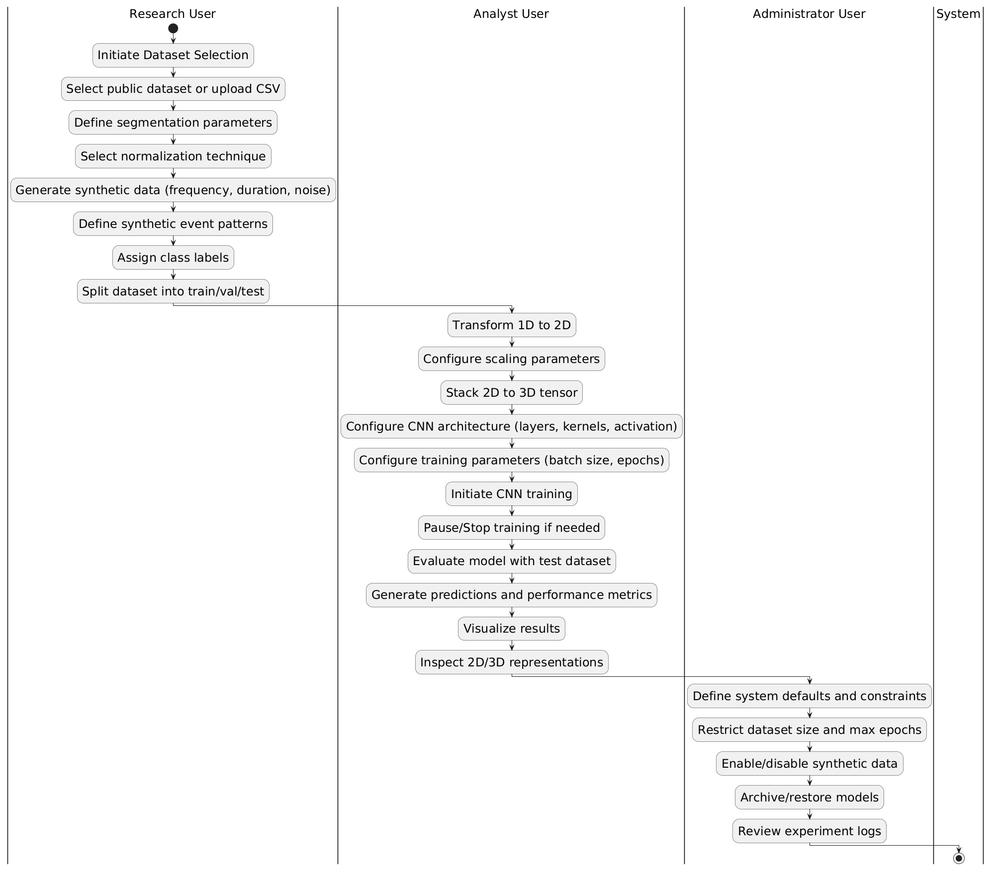
Diagram 2: Activity Diagram for “2D to 3D Time Series Classification Using CNN with Streamlit Dashboard”

